IAAF CERTIFICATION SYSTEM

Track and Field Facilities Measurement Report
Outdoor Facilities – Pole Vault

This form must be sent to: technicalofficer@iaaf.org

Address: IAAF, Att. Technical Manager, 6-8 Quai Antoine 1er, BP 359, MC 98007 Monaco Cedex

FACILITY
Name of Facility / Stadium:
Address:
City:
Country:
Telephone:
Fax:

Owner of Facility / Stadium:

Address:

E-mail:

SURVEY WORK
Surveyor Company:
Surveyor’s Name:
Qualifications:
Address:
Telephone:
Fax:
E-mail:
Date(s) of Survey: |  | Temperature:
Weather:

Instruments*: | Theodolite: |  | No.:
 | Distance Meter: |  | No.:
*Certificates of instrument accuracy shall be attached.
General:
Requirements are indicated. (See also “Commentary” on page 24!)
Test methods are explained.

Distances longer than 20m are to be measured by electro optical instruments.
Angles are to be measured by theodolite.

Facility for Pole Vault

 | IAAF Rule Requirement | Area A1 | Area B1 | Area A2 | Area B2
The runway | The length of the runway is:  minimum 40m, if possible 45m. | m | m | m | m
 | It has a width of: 1.22m ± 0.01 | m | m | m | m
 | It is marked by white lines 50mm in width. (Rule 183.6) | Y N | Y N | Y N | Y N
Inclination | The maximum lateral inclination of the runway is less than 1:100. | Y N | Y N | Y N | Y N
 | In the last 40m of the runway, the overall downward inclination in the running direction is less than 1:1000. (Rule 183.7) | Y N | Y N | Y N | Y N
Note: Provide runway levels at the box and at 10m intervals from each Pole Vault box. Use a separate drawing for providing the required spot levels.
Pole Vault box | Size material and construction of the Pole Vault Box is in accordance with the Rule. (Rule 183.8) | Y N | Y N | Y N | Y N
Zero line: | A white line 10mm wide is drawn at right angles to the axis of the runway, in line with the back end of the box. (Rule 183.1) | Y N | Y N | Y N | Y N

Runway surface:
Product name:
Product manufacturer:
Absolute Thickness: | mm
IAAF Product Certificate Number

Attachments
(Check mark the appropriate box below for each attachment provided with this report.)

Certificates of instrument accuracy.

Plan showing field event layouts (layout drawing).

Photographs showing the method of construction.

Runway levels at the box and at 10m intervals from each Pole Vault box.

Conclusions

The competition area was checked regarding layout, gradient and dimensional accuracy.

I hereby certify that all measurements and information shown in this report are accurate and are the result of a well-conducted survey.

Considering the attached measurements made during the inspection of the facility, I recommend that the facility be granted a confirmation of compliance with IAAF requirements.

YES NO

If the answer is NO please state below the reason(s) why the facility does not come under the IAAF Rules.

Date:
Surveyor’s Name:
Signature:

Outdoor Facilities Measurement Report Commentary

Introduction

All the information required in this proforma must be determined by the surveyor and he should not rely on any other measurement work that may have been done by others.

It is not for the surveyor or others to determine whether dispensations might be provided for any non-conformity with the IAAF Rules or the recommendations of the IAAF Track and Field Facilities Manual. These are matters for the IAAF alone to determine.

For ease of distribution of the report it is recommended that the report be in Word document or Adobe pdf format. It is also preferred that the measurements be typed onto the form. If for some reason that is not possible then the figures should be written clearly in black ink.

If there are more facilities than allowed for on the proforma, the same information as that requested should be provided for the extra facilities.

All measurements/calculations of length must be to the nearest mm. No negative tolerances are allowed in the measured distance of races.

Instruments

The surveyor must provide a current Certificate of Instrument Accuracy that can be traced back to national and international standards of measurement.

Competition Arena

This table must be completed in full. In IAAF terminology a single runway would have landing areas or Pole Vault boxes at each end or at the centre.

Runway Surface

The current list of track surfaces with IAAF Product Certificates is available on the IAAF website under Competitions/Technical Area/Certification System.

Spot Levels

Use separate drawings for providing the required spot levels.

Jumping runways: It is necessary that the questions for both ends of each runway, other than the high jump, be answered as the different direction of running could result in a different answer particularly regards the overall inclination in the direction of running.

It is essential that reduced levels not grades be provided on each of the runways at the intervals as requested on the proforma including the take-off board and at the planter box as appropriate.

The sign convention used by the IAAF for inclinations is that an upward inclination in the direction of running or throwing is positive. At any radius, the lowest level is compared with the throwing circle/runway level to determine the inclination.

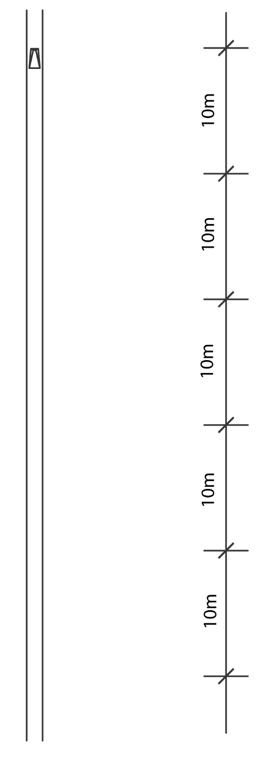

Name and City of Facility:
Site identification:

